* RESIDENTS BUSINESS GOVERNMENT SERVICES CONNECT

CONTACT US I **(t**

PROPERTY SEARCHQ.

Address **Map** Number Map Search **Search** Home

Profile Sales l(alues

Tax Details Residential Commercial Map

Structure Size

**MAP#:** 0384 02 0073

COLE LAURIE GENEVRO 124 COURTHOUSI

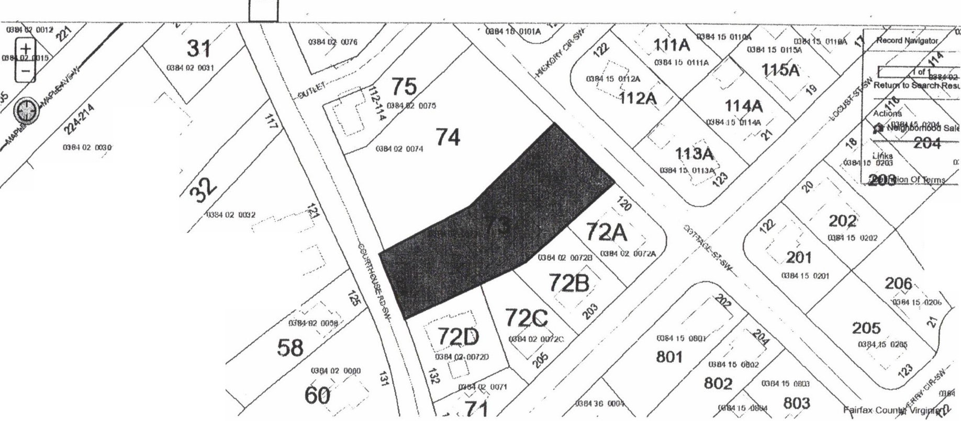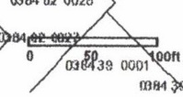

*/*

/

**3-0 '**

*/*

'·,..

/

/

/

, · . */'*

\ */*

**2***(***9A** *.J*

'

,·

·'

2(

mo,,,1.

'\_ll

*( ,/*

/ _/

**mll4 02 no:'J'r *57***

0384 02 0111.9,\

**28**

000]

« RESI DENTS BUSINESS GOVERNMENT SERVICES CONNECT

CONTACT US ! *(!£*

PROPERTY SEARCH Q

Address Map Number Map Search Search Home

Profile Sales Values

Tax Details Residential Commercial Map

Structure Size

MAP #: 0384 02 0073

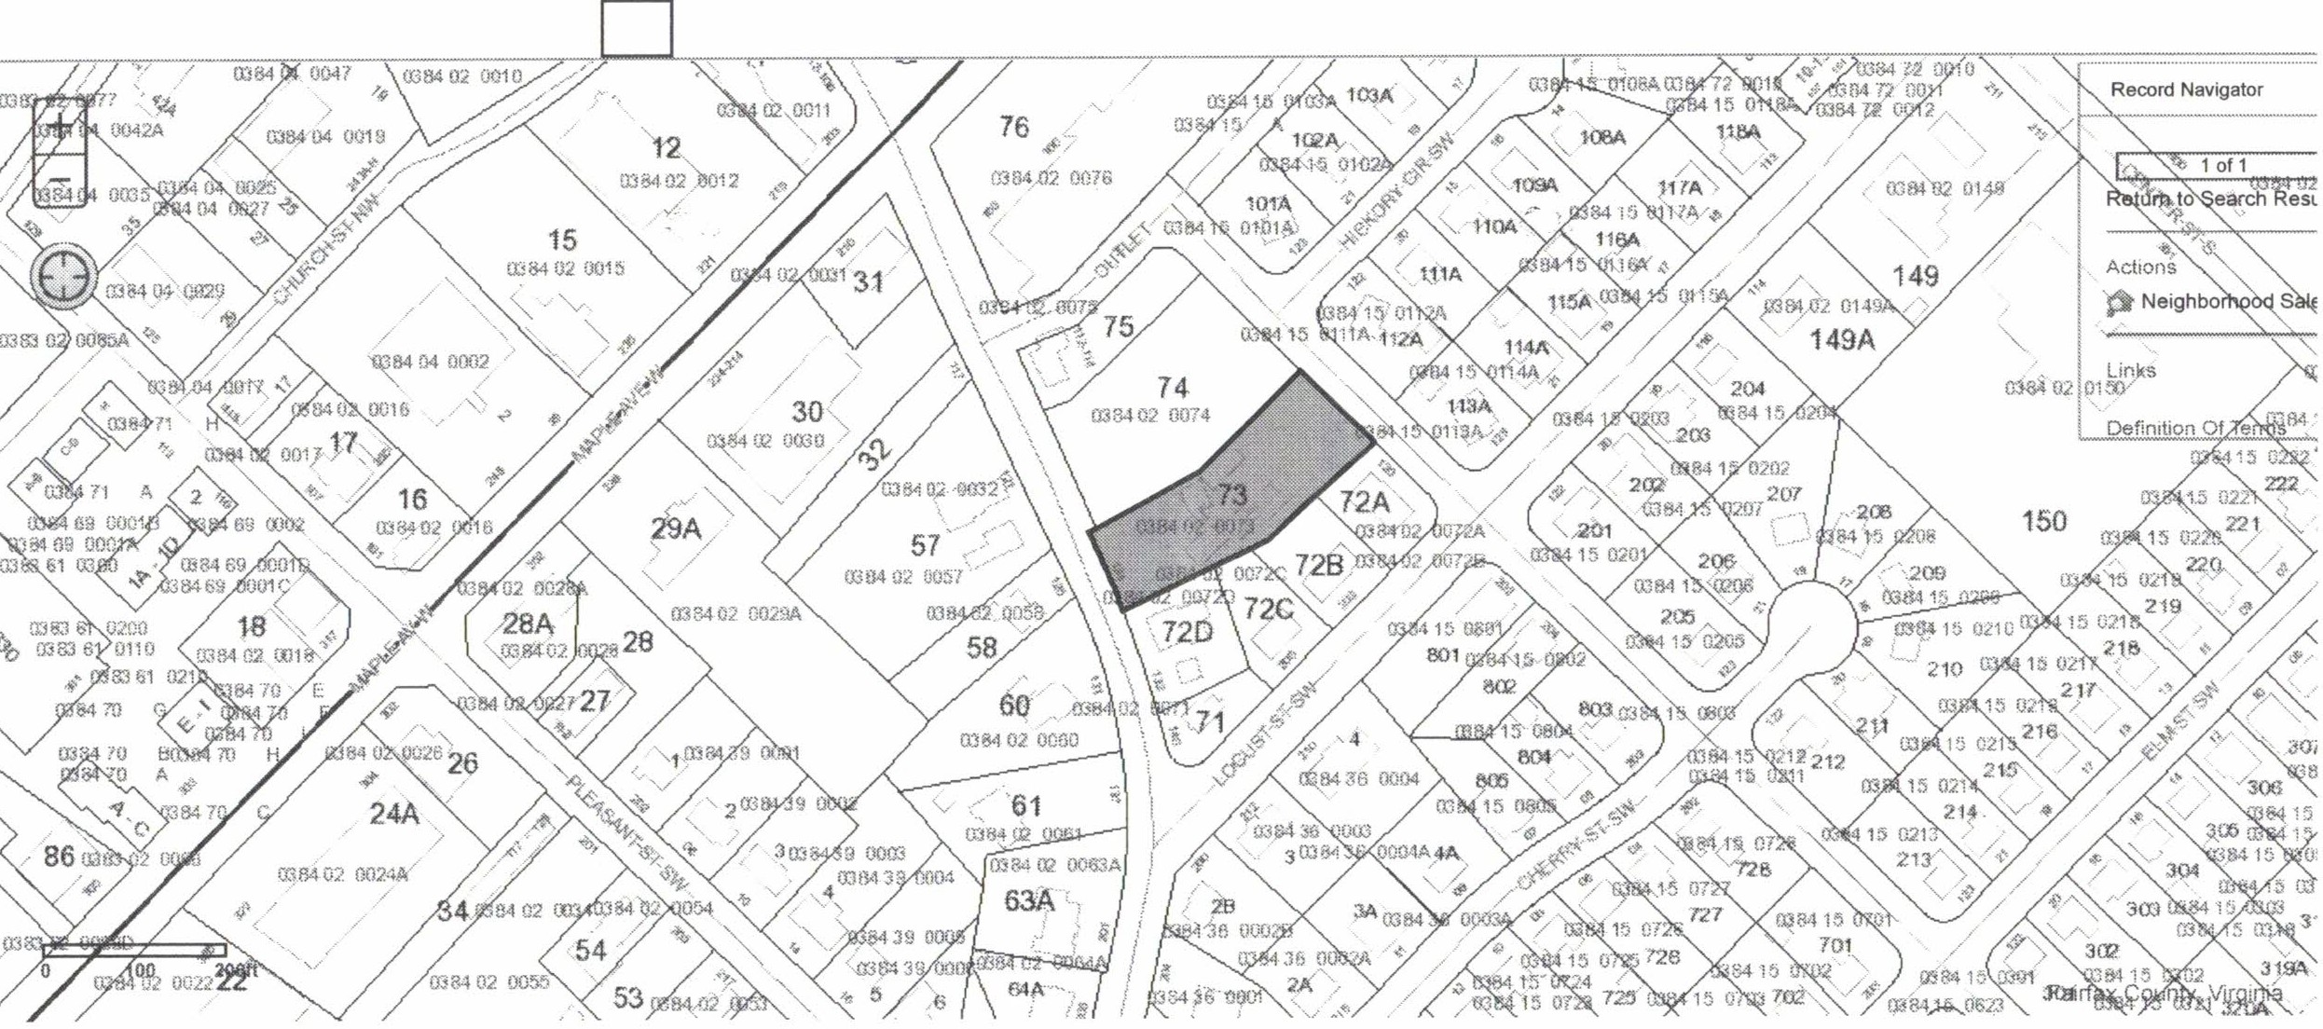COLE LAURIE GENEVRO 124 COURTHOUSI

, ; _ ,.