Virginia Real Est at e Board

http:lj [www.dpor.virginia.gov/Consumers/Di sclosure Forms/](http://www.dpor.virginia.gov/Consumers/DisclosureForms/)

**RESIDENTIAL PROPERTY DISCLOSURE STATEMENT**

**ACKNOWLEDGEMENT BY SELLER AND PURCHASER**

*' Virgi( 1*

*of*

|  |  |
| --- | --- |
| *i9) j* | |
| cl1, | it  .... t |
| ;1' d |

|  |  |  |
| --- | --- | --- |
| The Virginia R esid ential Property Disclosure Act(§ 55-517 et seq. of the | | *Code* |
| owner of certain residential real prop rty-whenever the property is to | be sold | |

as,

e

*er* l

**r**

e A, .

i

'.

*equ [res*

h an option

the

.

b .y·• \.th

o .r

f er the

·

ss+-s : d: l ·, .

at io

n

ll

1

to buy- to provide notification to the purchaser of any disclosures required

1

|  |  |  |
| --- | --- | --- |
| purchaser to thP Real Estate Board WE·bsit e referenced below for additional | info | rm |
| Cert ain t ran sfer s of residential property are excluded from this requirement | (se § | |

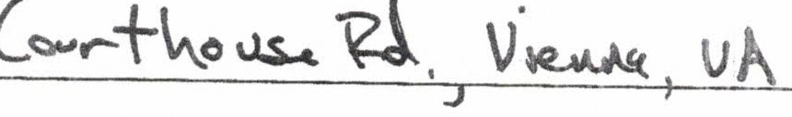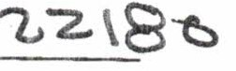PROPERTY ADDRESS/ LEGAL DESCRIPTION:

The purchaser is advised to consult the RESIDENTIAL PROPERTY DISCLOSURE STATEMENT webpage ([http://www.dpor.virginia.gov/Consumers/Residential Property](http://www.dpor.virginia.gov/Consumers/ResidentialProperty) Disclosures) for important information about disclosures required by law that may affect the buyer's decision to purchase the real property described above.

**The owner(s) hereby provides notification** as required under the Virgini a Re sid ential Property Disclosure Act(§ 55-517 et seq. of the *Code of Virginia)* and, if re presented by a real estate licensee as provided in§ 55-523, further acknowledges having been informed of

the rights a eAct.

C) v Jl{J *ZP*

Owner Owner

Date Date

**The purchaser(s) hereby acknowledges receipt of notificatio n** of disclosures as required under the Virginia Residential Property Disclosure Act (§ 55-517 et seq. of the *Code of Virginia).* In addition, if the purchaser is (i) represented by a real estat e licensee or

(ii) notrepresented by a real esta licensee but the owner is so represented as provided in

§ 55-523, the purchaser further acknowledges having been informed of the rights and obligations under the Act.

Purchaser Purchaser

Date Date

DPOR rev 07/10/17 v3.11

lnstanet FoR MS·